PolyNav is a path finding system to use with Unitys 4.3+ 2D system. One of the best benefits of PolyNav2D is its ease of use and setup. There are three prime components you should be aware of:

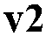 is the main component. You should place 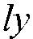 in your scene preferably on a new empty game object.

 is the component that you should attach on any game object that you would like to navigate around the world. This is not mandatory as you can create your own if you want to.

 is the component that most probably you arent going to use directly as it will be created through PolyNav2D, although you can place that component on a game object to manually create a naviga tion obstacle.


So the first thing you should do is create an empty game object and attach the PolyNav2D component or go to GameObject / Create Other / PolyNav2D. A PolygonCollider2D will automatically be attached as well. By using the default Unity controls for adjusting such a collider, you can define any shape for the navigation polygon.
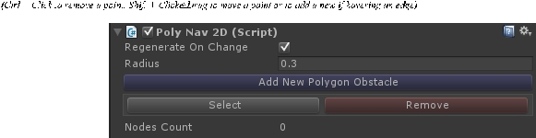

The Regenerate On Change toggle, will regenerate the map whenever any obstacle polygon change its position, rotation or scale, but keep in mind that this option might be very costly on performance.

As a side note, the map is either way regenerated whenever a new Obstacle is added or removed in play time. You can also generate the map manually by calling GenerateMap() on the PolyNav2D like so: PolyNav2D.current.GenerateMap();

The Radius settings is the offset that agents will have from the edges. Typically, you set this radius equal to the radius that the agents will have.

To create an obstacle (or a hole) within that main navigation polygon, click the Add New Polygon Obsta cle on the Inspector of the PolyNav, select that new obstacle and edit it just like you did the main polygon obstacle, since it also comes with a PolygonCollider2D. You dont have to be exact. You can have half an obstacle inside the walkable area.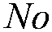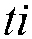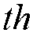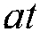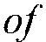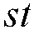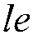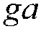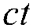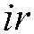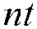

The PolyNavObstacle has one option to invertPolygon. If it is added when the gameobject already has an automated created PolygonCollider because of a sprite existing, it will be set to true. If you think something goes wrong it will most probably be because the exiting polygon collider is not inverted. So try to set this to true.
Select the game object that you want to be able to navigate within the map and attach the PolyNavAgent to it.
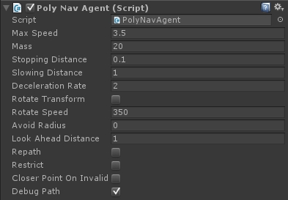

 is of course the maximum speed that the agent will move.
is the mass of the agent. The bigger the mass the more inertia it will have.
 is the distance from the goal that the agent will and consider reached.
 is the distance from the goal that the agent will begin slowing down.
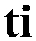 is the rate at which the agent will slow down when when reaching the goal.
 if checked will also rotate the agent.
 is the speed that the agent will rotate if Rotate Transform is checked.
 is the agent avoidance radius with other agents. Leave it at 0 if you dont need avoidance.
 is the distance that the agent look ahead for obstacles or other agents if other agents have an Avoidance Radius. You can set this value to 0, to disable obstacle and agent look ahead and in crease performance.
 if enabled the agent will revaluate and repath its current path for occasions where the map has changed. Disable for performance.
 if enabled will force the agent position within valid areas. Disable for performance.
 will make the agent go to the closer possible position if requested goal is invalid.  if checked will draw the path.

There are 2 demo scripts provided to move the agent about for a quick start.  and 

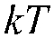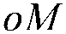 will simply move the agent at the clicked position while 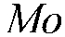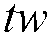 will move the agent between some way points at random selection.

Simply put either on the game object if you want a quick start.
Regarding scripting, there are 2 important function on the PolyNavAgent:

Sets a new goal for the agent. You can optionally provide a callback function which will be called on either arrival with a 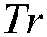 argument or if the destination is or becomes invalid with a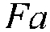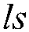 argument. The function itself return whether or not the destination is valid.

An alternative way instead of providing a callback function will be to subscribe to the events that the Poly NavAgent component raise:

OnDestinationReached

OnDestinationInvalid
OnNavigationStarted
OnNavigationPointReached<Vector2> (this is when a path node is reached)
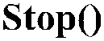

Will simply stop the agent from moving

There are also some important properties that you can use:

is any path pending right now for the agent?

does the agent has any active path

the next point in the path that the agent is moving towards

the remaining distance along the path for the goal

the direction the agent is currently moving


Notice that you can also request a path directly without using the PolyNavAgent component at all. You can do so like this:

The callback will provide the resulting path and a boolean to show whether a path was found or not.

Well thats it! Remember that you can enable Gizmos in play mode on the top right of the Game tab, so that you are able to view the polygon map, obstacles and agent paths for debugging.

Gavalakis Vaggelis nuverian@creativeminds.gr


